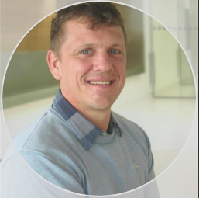

Michael Howard is the founder of Howard Integritas Solutions Ltd. (HISL) and creator of IntegAI, a sovereign AI platform designed for resilience, transparency, and human oversight.
Michael’s path into AI wasn’t through labs or lecture halls—it was through real life. When he set up HISL, he turned to AI to help manage the mountain of documentation, schedules, and communications that every new business faces. Around the same time, he began using AI to tackle DIY jobs at home—small fixes that saved time, cut through complexity, and gave him back headspace for bigger challenges.
That’s when the penny dropped. AI wasn’t just a gimmick; it was a genuine tool for getting things done. From there, Michael leaned into the simplest but most powerful method of learning: by doing. He started building his own AI systems piece by piece—testing, breaking, fixing, and iterating. Out of that process came IntegAI, an offline-first, human-in-the-loop platform shaped not in theory, but in practice.
Michael believes AI is here to augment, not replace. Through IntegAI, he is showing what’s possible when human judgment is essential, transparency is built in, and when we stop relying solely on distant cloud servers while underusing the powerful (and costly) devices already in our hands.
With over 20 years in construction, from site engineer to board-level governance, Michael brings the same builder’s mindset to AI: plan ahead, respect constraints, and create systems that last. His thought leadership—spanning LinkedIn, Substack, and CIOB—connects hard-won lessons from the field with a vision for AI that is sovereign, practical, and trustworthy.
At the heart of it all is a simple mission: to engineer intelligence like infrastructure—built to serve people, safe by default, and strong enough to stand the test of time.

